#SKILL - 6 ➔ Spring MVC Web Request Handling Demo
M.PRAVEEN REDDY 2400032662

Prerequisites:
- General Idea on Spring Web MVC and Form Handling
- Basic understanding of Spring Boot
- Understanding of HTTP methods (GET/POST)

An online library system wants to allow users to explore books, view specific book details, submit feedback, and interact with the system through various types of requests. To support these features, the backend team needs to implement multiple Spring MVC endpoints demonstrating request mappings, path variables, request parameters, and JSON data handling. Your task is to create a Spring Boot MVC controller that exposes different demo operations using @RestController, @GetMapping, @PostMapping, and @PathVariable.

Tasks:

- Create a controller class named LibraryController.
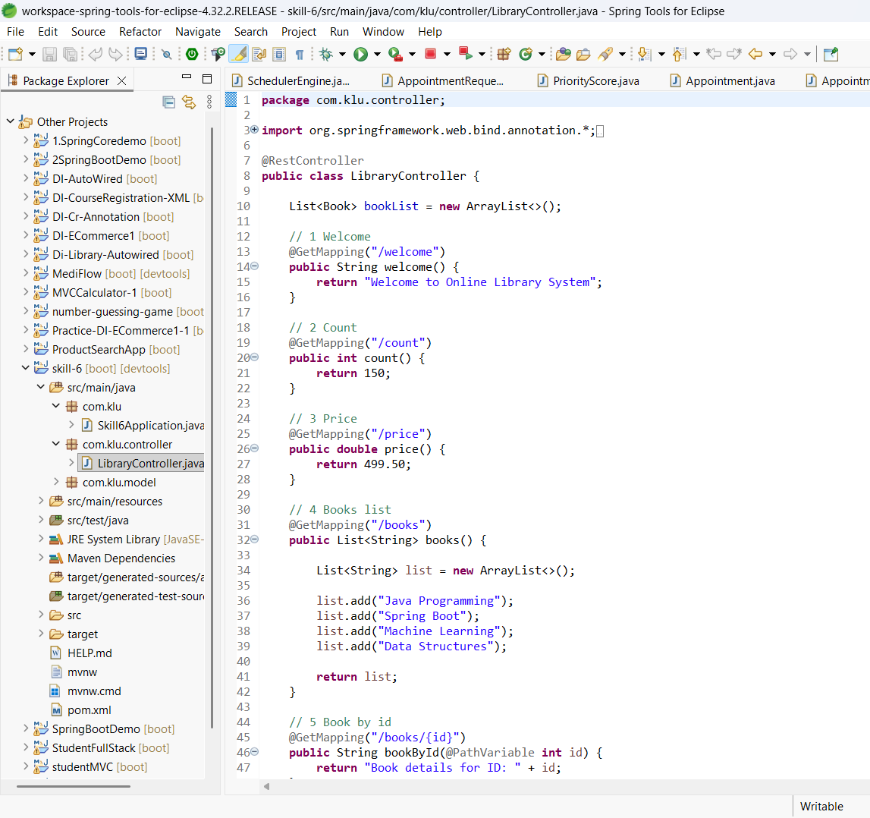
- Create a method mapped to /welcome that returns a welcome message.
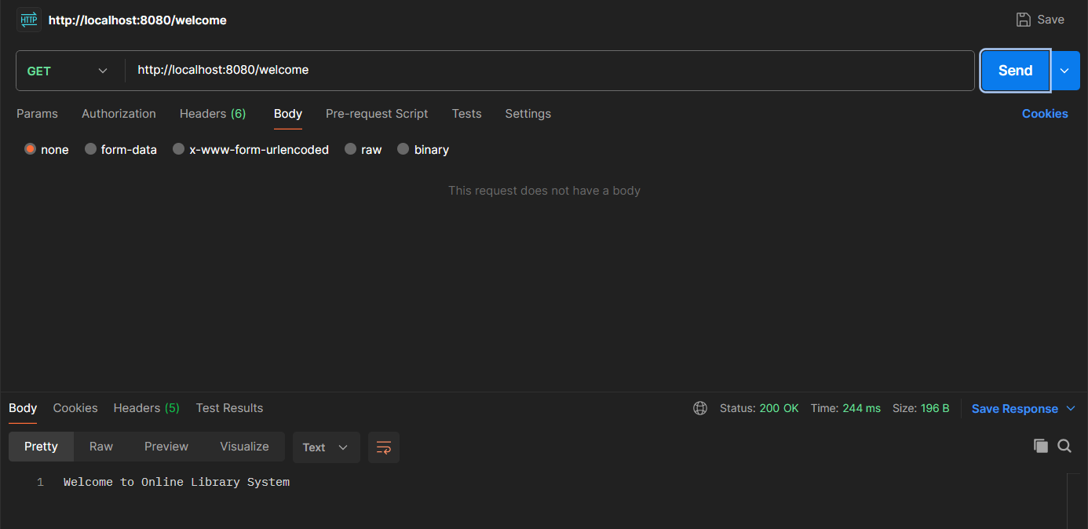
- Create a method mapped to /count that returns an integer representing total books.
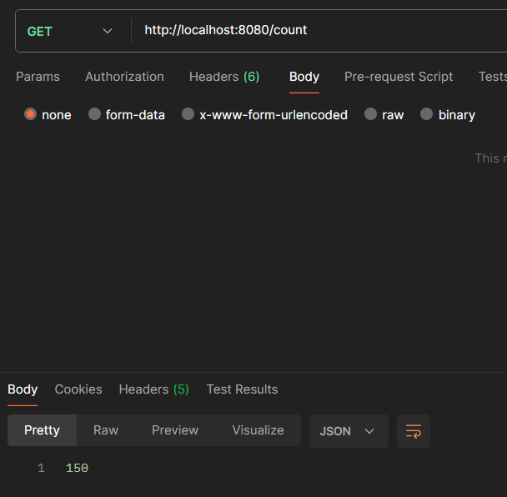
- Create a method mapped to /price that returns a sample book price as double.
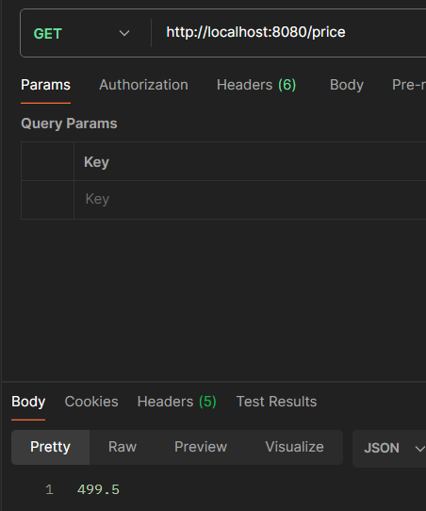
- Create a method mapped to /books using @GetMapping that returns a list of book titles.
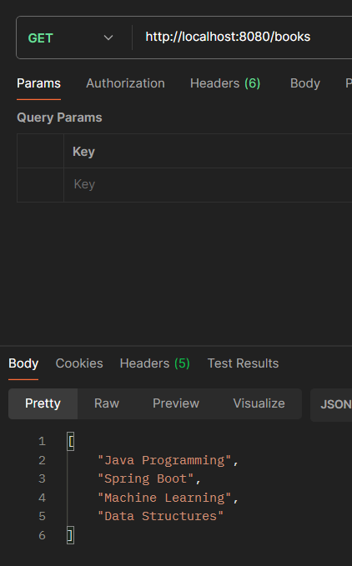
- Create a method mapped to /books/{id} using @GetMapping and return book details using @PathVariable.
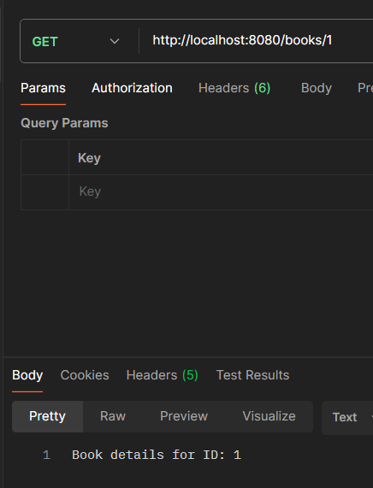
- Create a method mapped to /search using @GetMapping that accepts a request parameter (title) and returns a confirmation message.
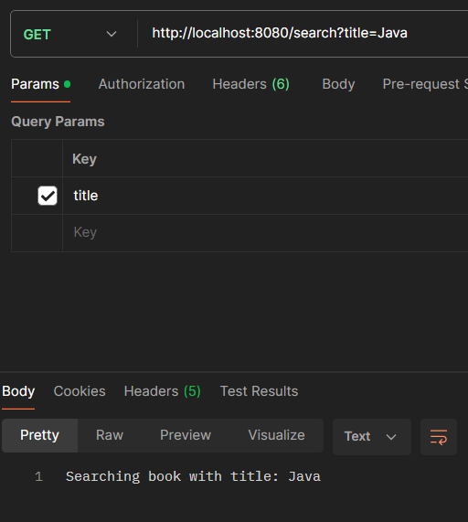
- Create a method mapped to /author/{name} using @GetMapping that returns a formatted message with the author’s name.
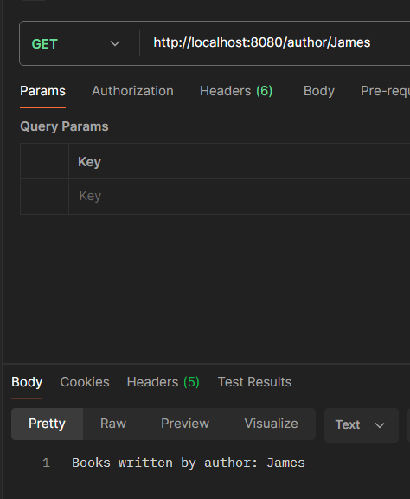
- Create a method mapped to /addbook using @PostMapping that accepts a Book object from the request body and adds it to an in-memory list.
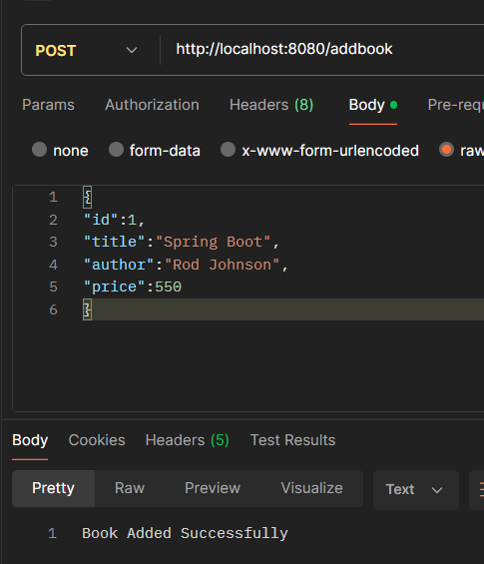
- Push the Spring Boot project to GitHub.
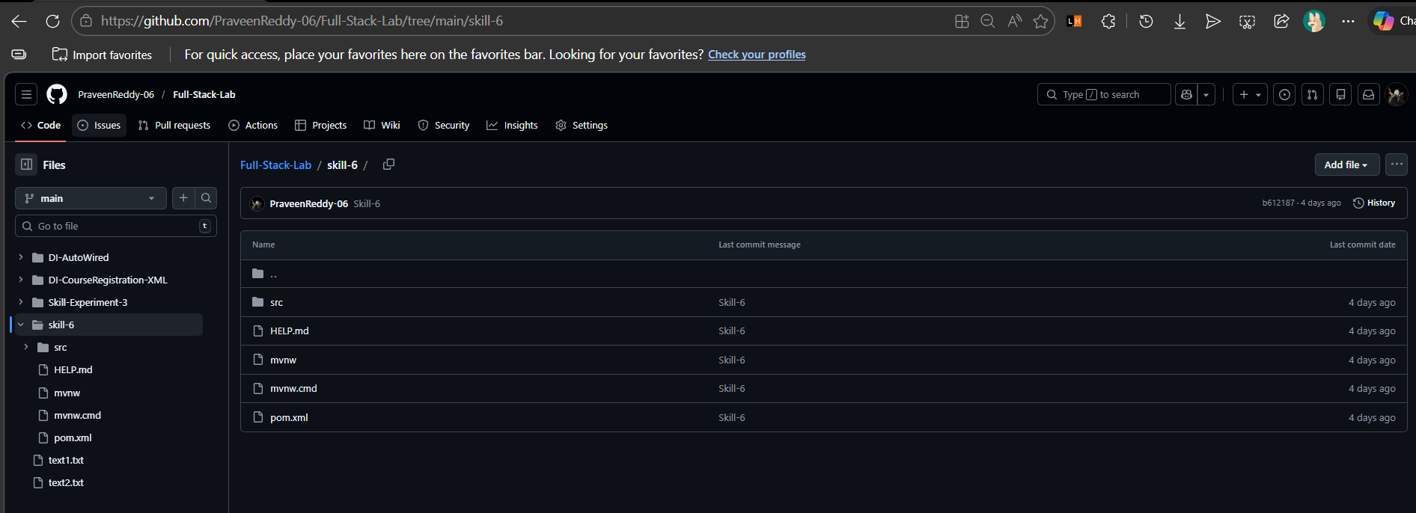
VIVA QUESTIONS:

- What is the role of @RestController in Spring MVC?
@RestController is used to create RESTful web services in Spring MVC. It combines @Controller and @ResponseBody, meaning methods return data (JSON/XML) directly instead of a view.
- What is the difference between @GetMapping and @PostMapping?
@GetMapping handles HTTP GET requests and is mainly used to retrieve data.
@PostMapping handles HTTP POST requests and is used to send or create new data on the server.
- How does @PathVariable help in handling dynamic URLs?
@PathVariable is used to extract values from the URL path and pass them as parameters to a controller method.
- When do we use @RequestParam?
@RequestParam is used to get query parameters from the URL or form data in a request.
- Can one controller contain multiple request-mapped methods?
Yes, a single controller can contain multiple request-mapped methods, each handling different URLs or HTTP request types.

(For Evaluator’s use only)

Comment of the Evaluator (if Any)

Evaluator’s Observation
Marks Secured: out of
EMP ID & Full Name of the Evaluator:

Signature of the Evaluator Date of Evaluation:

